**東海大學資訊管理研究所**

**碩士學位論文**

**應用雲端平台於複合式寵物醫院之資訊系統**

**Applying the Cloud Platform to the Information System for Compound Veterinary Hospital**

|  |  |  |  |
| --- | --- | --- | --- |
| **指導教授：陳** | **澤** | **雄** | **博士** |
| **黃** | **愉** | **閔** | **博士** |
| **研 究 生：許** | **哲** | **駿** | **撰** |

**東海大學資訊管理研究所**

**碩士學位論文**

**應用雲端平台於複合式寵物醫院之資訊系統**

**Applying the Cloud Platform to the Information System for Compound Veterinary Hospital**

|  |  |  |  |
| --- | --- | --- | --- |
| **指導教授：陳** | **澤** | **雄** | **博士** |
| **黃** | **愉** | **閔** | **博士** |
| **研 究 生：許** | **哲** | **駿** | **撰** |

審 定 書



誌 謝

光陰荏苒，如白駒過隙般轉瞬即逝，而青春也同飛鳥般，一去不復返。碩士的生涯即將到一個段落，回想起大學時期，從未想過自己讀完學士後會繼續攻讀碩士，當時只希望能快速畢業，踏入職場。然而，命運的轉輪，總是指向你意想不到的地方，在碩士求學的階段中，不僅改變了我人生的方向，同時也決定在畢業後，繼續踏入學術研究的領域。人生若寄，期望自己可以在有限的生命中，將所見、所學回饋給社會，對社會產生貢獻。聖經上說：「人若賺得全世界，賠上自己的生命，有什麼益處呢？人還能拿什麼換生命呢？」期望自己在面對忙碌複雜的世界，能夠保有初衷，活出豐富精彩的生命，為世界帶來光亮，如陳老師常說，要成為別人黑暗中的一盞明燈，照亮別人的生命，也照亮自己的生命。

我最要感謝我的指導教授，陳澤雄教授，不僅在我撰寫論文的過程中給予我許多的建議和方向，更給予我許多人生的建言，讓我對於人生的面貌有了許多不同的想法與看見，這是我碩士生涯，所學習到最寶貴的一門課程。

我要感謝擔任口試委員的沈榮麟教授，提出我許多文法及語句結構上的指點；鄭富國教授給予我在論文結構上的建議及調整；陳澤龍教授提醒我在文獻探討及系統功能說明上所不及之處；黃愉閔教授幫助我修改論文語句的表達方式，感謝口試委員的不吝指教，讓我的論文可以以更完整的形式呈現。

我要感謝雄家的小天使們，寶哥、尹姿、睏睏、耀民、博睿、岱倫、雅昕及郁婷，在我需要幫助時，不吝伸出援手，也要感謝口試當天前來幫忙的小天使們，讓我們能夠不慌不忙的將場地設置完成，另外我也要感謝雄家球球團的各位，讓我在撰寫論文的途中，可以透過打球來緩解煩悶的心情。

最後我要感謝一直在背後默默支持我的家人，感謝家人對我的期許，以及過程中所有的陪伴與幫助，沒有家人的支持與了解，我難以順利完成學業。

許哲駿 謹誌中華民國 106 年 7 月

論文名稱：應用雲端平台於複合式寵物醫院之資訊系統校所名稱：東海大學資訊管理學系研究所

畢業時間：2017年07月

研究生：許 哲 駿 指導教授：陳 澤 雄

黃 愉 閔

### 論文摘要：

隨著資訊科技的進步，有許多創新科技及應用，人們在思想以及生活習慣上與過去有很大的不同，也使得人們的生活方式朝向多元發展，而在建構起人們生活便利的社會下，同樣也有需要面臨的社會問題，例如，人口老化及少子化，是全球所共同面臨的問題，台灣的社會結構也正因為全球化的危機逐漸在改變。而隨著全球人口減少，家庭結構的改變，視寵物為伴或心靈寄託的對象，是目前日常生活中普遍可見的現象，寵物對於人們的定位，與以往不同，已經將寵物視為家庭中的一份子，在許多家庭中有著不可或缺的地位。

隨著寵物社會地位和飼主心中對於寵物疼愛度提高，寵物醫院不僅必須提升創意與創新服務，其也必須符合時代需求。根據農委會的粗估，臺灣的寵物市場每年約有超過新臺幣 200 億以上的產值。大型複合式的寵物醫院或連鎖經營的寵物醫院，都是異於傳統寵物醫院的一種選項，而大型複合式寵物醫院是傳統經營模式的多角化延伸，而近年來大型複合式寵物醫院及大型綜合寵物店皆有明顯的成長趨勢，根據農委會第 247 期的報告指出，目前台灣約有 5%的大型綜合寵物店，且正在逐漸成長。

本研究將透過文獻探討，整理探討台灣目前寵物醫院及商場的發展與現況，以及目前寵物市場的趨勢及成長，並進一步根據寵物醫院及商場的需求提供相關技術及服務流程上的改善。透過雲端平台的服務整合，以及 iBeacon 的室內定位技術，提供創新的服務與經營模式，來提高業者整體營運的效益及降低醫療風險發生的可能性，以提高顧客滿意度為目標。

關鍵詞：iBeacon、寵物醫院、資料探勘、雲端平台、遠端醫療

Title of Thesis：Applying the Cloud Platform to the Information System for Compound Veterinary Hospital

Name of Institute：Tunghai University, Graduate Institute of Information Management Graduation Time：(07／2017)

Student Name：Che-Chun Hsu Advisor Name：Tzer-Shyong Chen

Yu-Ming Huang

### Abstract：

Following the advance of information technology, there are lots of innovative technologies and applications. People show largely different thoughts and living habits from the past so that the life style appears diverse development. Under the constructed convenient society, many social problems would also be faced. For instance, population aging and low fertility are the common problems globally. The social structure in Taiwan is gradually changing due to the risk of globalization. With decreasing global population and changing family structure, regarding pets as companions or soulmates is currently a common situation in daily life. Pets have been regarded as family members and present absolutely essential status in many families.

With the enhancing social status of pets and the owners’ love, veterinary hospitals have to promote the creative and innovative service as well as meet the requirements of the time. According to the rough estimation from Council of Agriculture, the pet market in Taiwan presents the output value above twenty billion NT dollars every year. Large compound veterinary hospitals or chained veterinary hospitals are a different option from traditional veterinary hospitals, and large compound veterinary hospitals are the diversified extension of traditional business models. Large compound veterinary hospitals and large multi-purpose pet stores appear obvious growth trend in the past years. According to the 247 report from Council of Agriculture, about 5% large multi-purpose pet stores in Taiwan are growing at the moment.

This study is intended to discuss the development and current conditions of veterinary hospitals and stores and current trend and development of pet market in Taiwan through literature review, and further provides improvement of technologies and service procedures according to the requirements of veterinary hospitals and stores. With the integration of Cloud service and iBeacon, the indoor positioning technology, an innovative service and management model is provided to enhance the overall business benefits and reduce the possibilities of medical risks so as to promote customer satisfaction.

Key words: iBeacon, Veterinary Hospital, Data Mining, Cloud Platform, Telemedicine.

**Contents**

Chapter I Introduction 1

Section I Research Background 1

Section II Research Motivation 4

Section III Research Objective 4

Chapter II Literature Review 6

Section I Current Situation in Pet Markets 6

Section II Cloud Service 11

Section III Telehealth Care 14

Section IV iBeacon 17

Chapter III Research Methodology 22

Section I Conceptual Framework 22

Section II Platform Establishment and Planning 26

Section III Advantage of Integrated System 28

Chapter IV System Design 31

Section I System Construction Requirement 31

Section II Owner System Function 33

Section III Manager System Function 39

Chapter V Conclusion and Future Work 47

Section I Research Conclusion 47

Section II Research Restriction and Future Work 49

List of Figures

Figure 2-1 Statistics of the Number of Cats and Dogs from Council of Agriculture, Executive Yuan 6

Figure 2-2 Statistics of the Number of Veterinary Hospitals from Council of Agriculture, Executive Yuan 7

Figure 2-3 The Basic Structure of Cloud 12

Figure 2-4 The Conceptual Diagram of Telemedicine Care 16

Figure 2-5 Data Format Pack of iBeacon 18

Figure 2-6 The Levels of Distance 19

Figure 3-1 The Research Framework of Information System 22

Figure 3-2 Concept of Integrated Cloud Platform 24

Figure 3-3 Process of Product Recommendation System 25

Figure 4-1 Log-in Interface 35

Figure 4-3 Coupon Figure 36

Figure 4-5 Real-Time Image Interface 38

Figure 4-6 Veterinarian System Functions 40

Figure 4-7 Operator Management Platform Interface 42

Figure 4-8 Information System Manager Function 45

List of Tables

Table 2-1 Average Annually Expenditure for Pets (USA) 8

Table 4-1 The Equipment Requirements of the Integrated System 32

# Chapter I Introduction

## Section I Research Background

Following the advance of information technology, there are lots of innovative technologies and applications. People have shown largely different thoughts and living habits from the past so that the life style appears diverse development. Under the constructed convenient society, many social problems would also be faced. For instance, population aging and low fertility are the common problems globally. In addition to the influence under global socio-economic environment, people’s living habits also affect their physical, mental, and spiritual needs. The social structure in Taiwan is gradually changing due to the risk of globalization. With decreasing global population and changing family structure, regarding pets as companions or soulmates is currently a common situation in daily life. Pets, positioned from the early role of instrument to the current companions, have been regarded as family members and present absolutely essential status in many families [1].

According to the 2016 data from Department of Household Registration and Department of Statistics, Ministry of Interior, the population growth rate in Taiwan maintained above 10% before 1991, i.e. about two hundred thousand population growth per year. The population growth rate decreased annually afterwards, and it was merely 2.03% in 2016, meaning that the population growth was merely forty thousand last year. It revealed problem of social population structure in Taiwan that the proportion of a person supporting the elderly increased yearly with decreasing number of population growth. National macro-economy was the major factor in such a phenomenon. The effect of macro-environment resulted in young people being not easy to survive. The devaluation of a university degree had many people choose to continue graduate study, which indeed could not guarantee the work and survival capability. According to 2015

Report on the Manpower Utilization Survey from Directorate General of Budget, Accounting and Statistics, Executive Yuan, the major monthly income of people aged 20-24 and 25-29 was NT$25,105 and NT$31,824, respectively. In consideration of high expenses for fostering children, a lot of people were not willing to reduce the existing quality of life and considered to have children after being able to afford it that resulted in low intention of young people to raise children. As a result, the average age for marriage was enhanced and the intention to have children was reduced. According to the definition of World Health Organization, the population of seniors above 65 years old accounting for more than 7% total population is considered as an “aging society”. Taiwan became the aging society in 1993, when the 7% was exceeded. According to the 2016 data from Ministry of the Interior, the elderly population in Taiwan was about 12.78% that it was approaching an “aged society”. The problem of “low fertility and aging” results in the structural change in the composition of population in Taiwan as well as creates many singles and lonely seniors or DINK (dual income, no kids) that more and more people choose to raise pets instead of raising children. Some scholars advocate rectifying “pet” as “companion animal” that apparently shows people’s emphasis on pets [2]. According to the 2015 survey from TVBS, on average, one out of three people would raise cats or dogs. The 2015 data from Council of Agriculture, Executive Yuan, revealed the total quantity of cats and dogs in Taiwan was 2,282,177, which increased about 69.28%, compared to the total quantity of 1,348,130 in 2005. It showed the rapid growth of pet-raising in Taiwan [3].

Pets present certain effects of companionship and mind soothing. A lot of people

regard them as a family member so that the concern about pets is the same as them about family and their “food, clothing, housing, transportation, education, entertainment” and “birth, aging, sickness, death” are emphasized. Moreover, the advance of medical technology has various vaccines and testing drugs be innovated and extends the life of

pets. Traditional care of veterinary hospitals could no longer meet the requirements. The development of pet care should change the existing service, apply technology, and add innovative services to meet the requirements of humans and social development. Information technology, in the past decade, has guided the development of creative and innovative services in the world, and the development does not simply change people’s living and learning styles, but results in great impact on traditional corporate organization and business patterns. A corporate organization therefore has to adaptively change the service and direction.

With the enhancing social status of pets and the owners’ love, veterinary hospitals have to promote the creative and innovative service as well as meet the requirements of the time. There are more than three thousand veterinary hospitals and pets store in Taiwan, and the increasing demand for raising pets largely expands the market. According to the rough estimation from Council of Agriculture, the pet market in Taiwan presents the output value above twenty billion NT dollars every year. Large compound veterinary hospitals or chained veterinary hospitals are a different option from traditional veterinary hospitals, and large compound veterinary hospitals are the diversified extension of traditional business models [4]. Large compound veterinary hospitals and large multi-purpose pet stores appear obvious growth trend in the past years. According to the 247 report from Council of Agriculture, about 5% large multi-purpose pet stores in Taiwan are growing at the moment. Both large compound veterinary hospitals and large multi-purpose pet stores offer professional management, complete products, and quality service, with low prices, to replace the traditional veterinary hospitals and stores [5].

## Section II Research Motivation

The veterinary market in Taiwan is getting saturated, and the competition has become fierce so that the businesses have to review the management. In face of enormous customers and pet information, the past equipment and management could no longer meet the requirements. The businesses therefore have to propose new models to cope with the huge demand and information. Besides, large compound veterinary hospitals and pet stores are increasing in the past years so that the businesses have to effectively integrate the resources to develop the maximum benefits. The commonest problem in pet medical care is the medical dispute caused by the bloody service or process in the medical practice. Most pet owners do not have professional medical trainings that bloody pictures might result in pet owners’ discomfort and even induce psychological illness, e.g. posttraumatic stress disorder (PTSD) [6].

Cloud technology is getting mature in the past years. The decreasing cost for Cloud services allows a veterinary hospital reducing the overall equipment cost for establishing a management platform as well as promoting the customer satisfaction and customer loyalty through Cloud service. Both veterinary hospitals and pet stores present the trend to large compound stores. In this case, it is expected to combine the positioning technology in smart phones (iBeacon) to accurately position a consumer’s location in the store, acquire more consumer data, analyze consumer behaviors, and give real-time offers through smart phones to promote consumers’ purchase intention and enhance the business turnover.

## Section III Research Objective

According to the above research background and motivation, this study is intended to discuss the development and current conditions of veterinary hospitals and stores and the current trend and development of pet market in Taiwan through literature review and

further provides improvement of technologies and service procedures according to the requirements of veterinary hospitals and stores. With the integration of Cloud services and iBeacon, the indoor positioning technology, an innovative service and management model is provided to enhance the overall business benefits and reduce the possibilities of medical risks so as to promote customer satisfaction. The objectives of this study contain

1. The discussion of current conditions in the industry.
2. The discussion of technology and service models.
3. The discussion of iBeacon integrated Cloud service framework.

# Chapter II Literature Review

## Section I Current Situation in Pet Markets

The global economic development in past years has increased people’s income and enhanced the quality of life. Raising pets become an essential part of modern people’s life, and pets seem to become a member of human family. Accordingly, many pet industries are emerged, such as pet hospitals and pet stores. According to the 2015 survey from TVBS, average one out of three people would raise cats or dogs. The latest statistical information from Council of Agriculture, Executive Yuan, revealed that there were 567,939 domestic cats and 1,714,238 domestic dogs in 2015. The total quantity of cats and dogs slightly decreased than it in 2013, but the growth rate in the past decade was up to 69.28%, showing the rapid growth of the number of pets in Taiwan, Figure 2-1 [3, 7].

2,500,000

2,000,000

1,500,000

1,000,000

500,000

-

2005 2007 2009 2011 2013 2015

Cats 216,756 280,638 281,600 302,846 578,993 567,939

Dogs 1,131,374 1,321,438 1,271,920 1,241,910 1,741,602 1,714,238

Figure 2-1 Statistics of the Number of Cats and Dogs from Council of Agriculture,

Executive Yuan

The rapidly increasing number of pets enhanced the boom of pet market. According to the 2017 statistics from Council of Agriculture, there were 1,000

veterinary hospitals with certificated veterinarians in Taiwan. The statistical data included 2002-January, 2017, covering 407 veterinary hospitals in the north (Taipei, New Taipei, Keelung, Taoyuan, and Hsinchu), 275 in central Taiwan (Miaoli, Taichung, Nantou, Changhua, and Yunlin), 287 in the south (Chiayi, Tainan, Kaohsiung, and Pingtung), and 31 in the east and offshore islands (Taitung, Hualien, Yilan, Kinmen, and Penghu). The number of veterinary hospitals rapidly increased after 2009 and maintained the increase of 80 veterinary hospitals per year. The statistics showed that 122 veterinary hospitals received the practice license from 2016 to January, 2017. Overall speaking, pet hospitals in Taiwan appear steady growth [8].

140

120

100

80

60

40

20

0

|  |  |  |  |  |  |  |  |  |  |  |  |  |  |  |  |
| --- | --- | --- | --- | --- | --- | --- | --- | --- | --- | --- | --- | --- | --- | --- | --- |
|  |  | | | | | | | | | | | | | | |
|  | | | | | | | | | | | | | | |
|  | | | | | | | | | | | | | | |
|  | | | | | | | | | | | | | | |
|  | | | | | | | | | | | | | | |
|  | | | | | | | | | | | | | | |
|  | | | | | | | | | | | | | | |
| 2002 | 2003 | 2004 | 2005 | 2006 | 2007 | 2008 | 2009 | 2010 | 2011 | 2012 | 2013 | 2014 | 2015 | 2016 |
| Numbers | 24 | 39 | 41 | 51 | 72 | 55 | 64 | 49 | 70 | 88 | 76 | 86 | 75 | 81 | 122 |

Figure 2-2 Statistics of the Number of Veterinary Hospitals from Council of Agriculture, Executive Yuan

According to the business registration information from eTax Portal, Ministry of Finance, there are 2,725 registered pet stores which are still in business in Taiwan. The 2016 report of Agricultural Technology Research Institute pointed out the increasing number of pet wholesale stores, veterinary drug retail stores, pet retail stores, pet supplies retail stores, pet food retail stores, and pet care and training stores over the past

5 years in Taiwan. However, the report also revealed that the revenue in 2016 obviously decreased, comparing to it in 2015, despite the obvious increasing number of stores. It revealed the fierce competition in the pet market. A lot of businesses started the business to grab the pet market. Nonetheless, the benefits were decreasing with the gradually saturated market. In face of such a fiercely competitive market environment, businesses needed innovative thoughts to maintain the competitive advantages [9].

Animal medical industry, the largest pet market segment in the USA, the country with the largest market for pet industry, presents about 50% market share. According to the 2017 pet survey data from APPA, the average expenses for a pet dog was about 1,549 US dollars, and 988 US dollars for a pet cat, per year. Table 2-1, show in which the expenses for surgical treatment was the highest, followed by routine treatment, pet food, and pet boarding [10].

Table 2-1 Average Annually Expenditure for Pets (USA)

|  |  |  |
| --- | --- | --- |
|  | Dogs | Cats |
| Surgical Vet Visits | $474 | $245 |
| Routine Vet | $257 | $182 |
| Food | $235 | $235 |
| Kennel Boarding | $322 | $164 |
| Food Treats | $72 | $56 |
| Vitamins | $58 | $46 |
| Groomer/Grooming Aids | $84 | $30 |
| Toys | $47 | $30 |
| Total | $1,549 | $988 |

On the other hand, Industrial Technology Research Institute indicated in the 2013 research report that the average monthly expenditure for cats and dogs in Taipei City

was 1,778 and 2,740 NT dollars [11]. Apparently, US pet owners would spend average annually 29,640 and 46,470 NT dollars on pets, while it was 21,336 and 32,880 NT dollars in Taiwan. The 2016 research of Agricultural Technology Research Institute indicated that the revenue of pet industry in 2015 was 22.8 billion dollars, according to the statistics database of Ministry of Finance [9].

Tsou (2007) proposed 7 characteristics with the business model of pet hospitals as follows [12]:

1. A veterinary hospital, as an emerging service industry, serves pets and pet owners, where pet owners pay for the expenses, and both pets and pet owners enjoy services.
2. A veterinary hospital’s service presents instantaneity as the service content would be instantaneously changed or adjusted according to a pet owner’s request.
3. A veterinary hospital is a labor-intensive industry, as the provided service requires the operation of service personnel.
4. A veterinary hospital emphasizes the technical proficiency of service personnel, who have to present sufficient technical proficiency and constantly make reinforcement to face various requests from pet owners.
5. Veterinary hospitals present differences in various service areas, and different service personnel show distinct service styles. The exchange shows mutual dependence, and each unit requires high communication skills and teamwork skills.
6. Veterinary hospitals are a part of pet market that business operators need have national practice licenses. It is mandatory that not everyone can practice the business. Besides, the acquisition of certificates requires professionalism to make it difficult to acquire a certificate. However, there are many people

engaging in the business to result in fierce competition among veterinary hospitals in the past years.

1. Most veterinary hospitals are private businesses, rather than state-owned, that the business hour is comparatively longer. A lot of time is spent on waiting for pet owners that it could easily result in service personnel’s fatigue disease.

In the discussion of key success factors in the business of veterinary hospitals, Chen (2002) classified veterinary hospitals into four types of (1)single-store business, (2)contractual joint venture, (3)multi-store business, and (4)chain business. According to current market situations, Chang (2011) proposed the fifth type, combinative business, which combined pet industries of pet beauty, pet medical care, and pet supplies to form the new business model. In the research on the development of pet industry in 2013, the Council of Agriculture mentioned that the traditional pet stores, about 80%, were ranked on the top in Taiwan, chained pet supplies stores about 15%, and the new business model, multi-purpose pet stores, about 5%, which reduced prices by largely purchasing relevant products and provided professional business, complete products, and quality service to replace the traditional pet hospitals and stores. In the research on compound veterinary hospitals, Liu (2009) concluded the significant effect of service quality on the customer satisfaction and loyalty, presenting the importance of service quality offered by compound veterinary hospitals for consumers [5, 12-14].

According to current situations in the pet market, the rapidly increasing number of pets and the steady growth of veterinary hospitals in Taiwan represent the boom of pet market in the past years, where the business pattern of combinative pet stores becomes the trend and is the discussed subject in this study. However, under the trend of increasing number of stores in pet industry, the research of Agricultural Technology Research Institute revealed the decreasing sales revenue, showing the gradual saturation of the market. Businesses in pet industry therefore have to think of new business

patterns to maintain the competitiveness. It is proposed in this study that information technology provides more efficient management and product marketing processes for businesses enhancing the overall revenue and creating the competitiveness.

## Section II Cloud Service

There are various statements about the origin of Cloud. According to the data in Baidu Baike, people often use a cloud to substitute the idea of network when drawing illustrations. Cloud therefore becomes a metaphor of network, an abstract idea for the hidden complicated infrastructure. Kaufman (2009) regarded Cloud as the term generated from telecommunications network applying VPNs to establish the environment with constant bandwidth network, low maintenance cost, cross-network use efficiency, and dynamic routing [15]. Cloud was not a brand-new technology, but a new network application combined with various technologies, where “cloud” stands for the network service of data transmission, and “end” is referred to as the user accessing network service with end devices [16-17].

The idea of Cloud computing was first proposed by the Google founder in the search engine conference held in 2006. The application of Cloud computing was then boomed after the idea being proposed. Google and IBM also promoted the Cloud computing plan in universities in the following year [18-20]. Foster et al. (2008) considered that, different from the traditional computing, Cloud computing was flexible, could be packaged an abstract entity, and provided customers with different levels of service under the drive of economy of scale and dynamically configurable service [21]. According to Huang’s research report in 2009, the simplest meaning of Cloud computing was to use computing capability as a service for all individuals or enterprises simultaneously proceeding computing with different computers through the Internet to largely enhance the processing speed. Besides, the required data items were not

necessarily stored in personal computers; instead, such data items could be stored in “Cloud”, anywhere the network allowed [22]. Yu et al. (2010) indicated that Cloud computing was a kind of distributed computing technology, which distributed the resources, which users required for the computing, to various servers and aggregated the results in order to reduce the computing load of a single server [23]. The basic structure of Cloud is shown in Figure 2-3 [24].

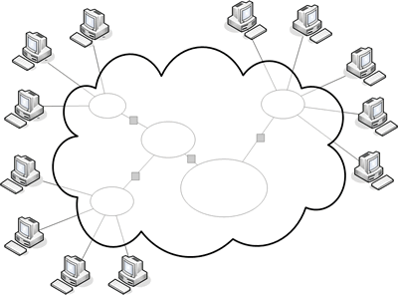

Figure 2-3 The Basic Structure of Cloud

NIST (National Institute of Standards and Technology) pointed out five features of Cloud computing [25].

1. On-demand Self-service: Users could use Cloud service for personal demands, without exchanging and interacting with a Cloud service provider.
2. Broad Network Access: Network is ubiquitous that Cloud service could be used through heterogeneous customer-end platforms, e.g. mobile phones, tablets, and laptops.
3. Resource Pooling: A Cloud service provider gathers all available resources and equipment in a resource pool and assigns physical devices or virtual software according to Cloud service users, who normally could not know the actual

location of resources.

1. Rapid Elasticity: Cloud service could rapidly compute and flexibly adjust software or hardware according to service requester’ requests.
2. Measured Service: Various steps, procedures, and levels in Cloud service are controlled by Cloud service providers. It could help the access control, the optimization of processing capability, and the calculation of expenses and provide consumers with the transparent Cloud service information.

Park et al. (2014) considered that Cloud computing was an infrastructure and system, and the data storage and computing were completed through the Cloud service provider’s equipment, without the computing of electronic devices. Besides, the computing equipment did not need maintenance that it could effectively reduce costs and provide more efficient service [26]. McFedries (2007) pointed out Cloud computing as a user being able to access any Cloud service through electronic devices or mobile devices at any time [27]. Chung et al. (2010) regarded Cloud computing as the presentation of customized service based on user needs, offering correspondent pricing for pay-per-view or charge by flow [28]. Peng et al. (2010) pointed out the loose definition of Cloud computing that whatever presented the characteristics of flexibility and expandability, but not necessarily in the computing structure of cluster computers, were considered as Cloud computing [29]. Buyya et al. (2009) mentioned that Cloud computing seemed to be a cluster network, but it was actually a virtual computing center with nodes, meaning to provide correspondent equipment according to individual needs, rather than proceed computing through cluster [30]. Cloud service contains three models of Infrastructure as a Service, Platform as a Service, and Software as a Service [31].

1. Infrastructure as a Service (IaaS): Providing users with the utilization of all computer infrastructures through the Internet. Alibaba, Microsoft, and IBM

currently select Iaas.

1. Platform as a Service (Paas): Providing users with a software development platform as the service.
2. Software as a Service (Saas): Software could be used through the Internet, without worrying about the software update and upgrade, and presents the characteristics of flexibility and convenience.

Wu (2011) reported SaaS as the most popular model, among the three. SaaS functioned to establish software for deployment as well as provide software maintenance that it presented larger convenience for small and medium enterprises, comparing to traditional software supplier [32]. Comparing traditional enterprises with those applying Cloud computing, Chen (2012) indicated that veterinary hospitals applying Cloud computing for the information integration would largely reduce the cost as well as completely record each pet owner and the pet’s medical reports [33].

From the above characteristics and service models of Cloud computing, Cloud service contains more advantages of lower costs and self-service of users. Cloud service becomes essential for the development of modern enterprises, as it could help an enterprise reduce costs. The advantages and characteristics of Cloud service are also applied to this study, and the system structure is established on the Cloud service platform.

## Section III Telehealth Care

In the end of 1950s, Wittson and Nebraska, the US scholars, applied television systems to medicine. Later on, medical scholars in the USA constantly applied electronic technology to medical activity to gradually appear the term, Telemedicine. Lin (2013) indicated that the term, telemedicine, first appeared in 1970s, aimed to improve a patient’s distance treatment through the use of information technology, e.g.

distance image diagnosis and distance treatment. World Health Organization described that whatever exchanged valid information with information and communications technology (ICT) for disease and injury diagnoses, treatment and prevention, research and evaluation, and health care service provided by health care service providers for the continuous education of health care practitioners, where distance was a key factor and the objective was to promote the health of individuals and communities [34]. Kuszler (1999) simply defined telemedicine as “simple, but useful”; telemedicine allowed medical personnel contacting, diagnosing, inquiring, and providing patients with treatment programs through remote communications devices [35]. Telemedicine was a new-style medical system, with the functions of (1)enhancing home safety, (2)active system reminder, (3)detecting security of activity, (4)detecting physiological information, (5)transmitting real-time message, and (6)abnormity reminder [36-38]. Chen (2004) pointed out the service contents of telemedicine, including (1)retrieval of physiological information, (2)communication and coordination of care service, and (3)assistance in self-health management. Lin (2013) expanded those with (4)communication and video equipment for contacting with case managers and

(5)health education web sites established by medical institutions [34, 39]. Lewis (2012) considered that telemedicine could enhance the opportunities for backward areas acquiring professional medical enquiries [40]. Ward (2015) proposed that mild diseases could be treated through telemedicine to solve the urban-rural divide problem [41].

Telemedicine breaks through the restrictions on time and space and could provide residents in rural and remote districts with complete medical service [42-43]. Tsai (2011) classified modern telemedicine into two categories. The first used advanced network technology as the communication media between patients and physicians for video diagnoses. The second utilized modern hi-tech medical equipment for the self-use of distance patients, who then returned the physiological data to physicians [44]. Cheng

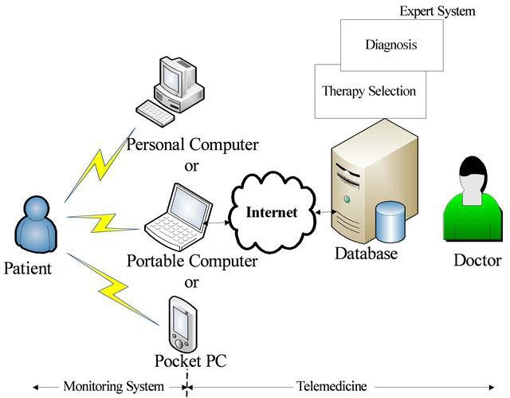(2013) indicated that telemedicine could share resources, reduce costs, and break through the restrictions on time and space. The application of information technology allowed clinics in remote districts acquiring the professional consultation, video meeting, and distance diagnosis from medical centers [45]. Hsieh (2014) mentioned that telemedicine first appeared in Taiwan on “Telemedicine Pilot System Experiment Project” proposed by Ministry of Health and Welfare in 1995, in which telemedicine was proceeded in clinic in remote districts through urban medical centers so as to shorten the rural-urban medical gap. According to “Telehealth Service Development Project – Special Assignment Office”, Ministry of Health and Welfare established distance intelligent health care service development enquiry team in 2016, expecting to provide long-term professional consultation through the professional knowledge and capability of Taiwan Hospital Association to strengthen the telemedicine related programs and the promotion of regulations [46-47]. The conceptual diagram of telemedicine care is shown in 2-4 [48].

Figure 2-4 The Conceptual Diagram of Telemedicine Care

In the research on the distance video health care platform for veterinary hospitals, Chen (2014) indicated that monitoring wards in a veterinary hospital through video equipment, connecting distance monitoring with the network platform in a veterinary hospital, and offering a platform device between pet owners and medical personnel allowed both parties acquiring the real-time video images and relevant information as well as guaranteed the rights and obligation of both parties [6]. Wang (2016) mentioned the advantages of applying telemedicine to veterinary hospitals, in the research on veterinary hospital management systems, that (1)a veterinarian could see a pet, which appeared sudden disease at home, through telemedicine and give suggestions, (2)it could reduce the cost for personnel’s caring and introduce in prevention medicine, and

(3)the use of telemedicine could easily achieve the resource sharing between patients and veterinarians [49].

Corresponding to the development trend of telemedicine, this study intends to apply telemedicine to pet hospitals and establish an integrated system for uploading a pet’s physiological conditions to the Cloud platform to achieve the objectives of resource sharing between pet owners and veterinarians so as to real-time understand the pets’ physiological conditions, reinforce the communications between pet owners & pet hospitals, offer pet owners with convenient service, as well as reduces costs for pet hospitals to enhance the trust between both parties.

## Section IV iBeacon

iBeacon was first proposed by Apple Inc., aiming to enhance consumers’ shopping experiences in Apple Store through indoor positioning. iBeacon presents the characteristics of low power consumption, low costs, and easy detection. Signals could be received to execute correspondent commands, e.g. anti-theft and anti-loss of the elderly with mobile phones, through electronic devices or other devices which could

receive Bluetooth signals, such as Raspberry Pi [50]. iBeacon, the Bluetooth Low Energy (BLE) equipment powered by Coin Cell or external batteries, is a part of Bluetooth 4.0 specifications proposed by Bluetooth Special Interest Group (SIG) in 2010. Simplex and Duplex models are also developed for Bluetooth 4.0. The former is suitable for devices with long-period connection but not continuous data transmission, and the latter could transmit data between devices with different specifications, according to requirements [51]. Lin (2017) pointed out the characteristics of Bluetooth

4.0 that it could select the transmission rate and choose pure receipt, transmission, or both, as well as apply to sports, medical treatment, intelligent family, and health detection [52]. Major Bluetooth products in the market with Bluetooth Low Energy, originated from Nokia’s Wibree, are classified into three categories.

1. Simply supporting traditional Bluetooth devices.
2. Supporting both traditional Bluetooth and LE-model Bluetooth Smart Ready devices.
3. Simply supporting LE-model Bluetooth Smart devices.

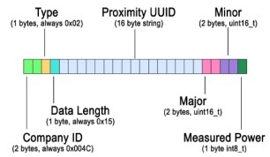New-style mobile devices and tablet computers suitable for Bluetooth 4.0 are regarded as Bluetooth Smart Ready devices. It is presently applicable to iOS version 7.0 and Android version 4.3 and would deliver special data format pack, as the figure 2-5[53-54].

Figure 2-5 Data Format Pack of iBeacon

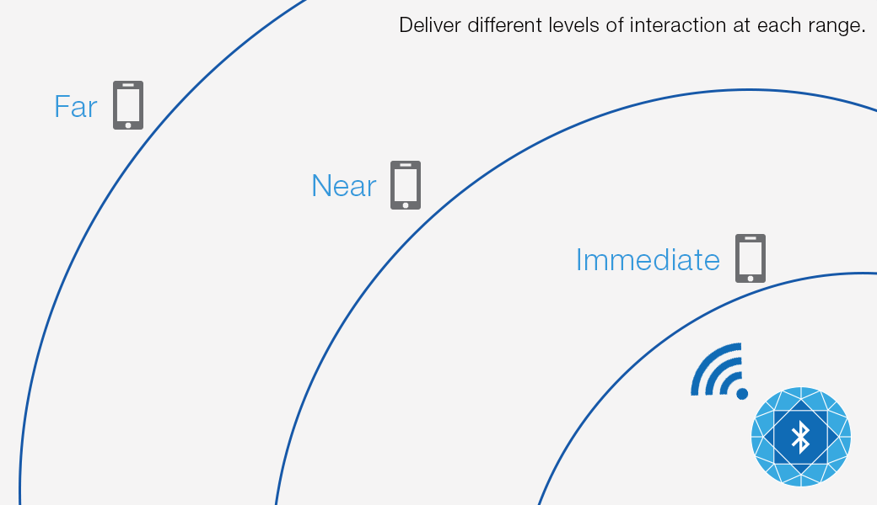The above figure shows the iBeacon special data format pack, which starts the initial 2byte of the company ID and followed by 1byte of type and 1byte of data length. Such four bytes are fixed, not being changed. The following 16byte close to UUID is used for identifying iBeacon, and the values of Major and Minor could be revised for identification or grouping. The last 1byte is Measured Power, used for receiving data and calculating the distance between iBeacon and devices. The working principles of iBeacon appear that iBeacon would deliver signals containing Received Signal Strength Indication (RSSI) to surrounding devices, and users could receive the signals from surrounding iBeacon through personal iOS or Android to judge the current position through identification signals. The received RSSI signals are divided into immediate, near, and far. Immediate refers to the reading area within 1m, near refers to 1-3m, and far refers to more than 3m, Figure 2-6. An obstacle between iBeacon transmitter and reader would affect the signal receiving strength to result in incorrect positioning. iBeacon could combine with Positioning Algorithm to enhance the precision [55-57].

Figure 2-6 The Levels of Distance

Lee (2015) integrated iBeacon with Big Data Analysis in the shopping recommendation service and mentioned that the triangulation of iBeacon presented the advantages of small calculation quantity, better precision at open terrain, and convenient establishment of hardware equipment. Meanwhile, it showed the drawback of the precision being easily affected by obstacles. Such an approach used the geometric characteristics of triangle. The specific process was shown as following. First, an object or a person equipped with a transmitter (as pets receiving medical treatment in pet hospitals in this study) with unknown position should be measured. Three readers are distributed within the area where RSSI signals could be received. The strength of RSSI signals received by the three readers is compared with the actual distance, and the specific position of a transmitter is calculated through the characteristics of triangle. The research results reveal that signals would be affected by the position on which a consumer holding the device. Such a problem could be solved through LandMarc algorithm and increasing the number of transmitters. Enhancing the transmission and receiving frequency of transmitters and readers could enhance the real-time positioning [56, 58]. Lin (2016) indicated that single-point Beacon position was comparatively inaccurate that the RSSI threshold should be enhanced to promote the precision. Two-point Beacon positioning was not suitable for broad areas, as the position of the tested object appeared hyperbola after the algorithm. Multi-point Beacon positioning showed more accurate positioning information, but consumed more resources [59]. Wu (2016) concluded that Beacon presented good positioning results in parking management and 100% accurate rate to judge parking space [60]. Chang (2015) applied iBeacon to campus security patrol systems and successfully established the check-in function so that managers could master the real-time positions and the patrol routes of patrol guards [61].

Research showed that Beacon presented the advantages of low power consumption, better precision at open terrain, and convenient establishment of hardware equipment. A lot of domestic research on Beacon showed good results, revealing the application trend of Beacon. According to the research background, motivation, and literature review, it is discovered in this study that pet market is getting saturated. Although the total number of pet-related stores was increasing, the revenue appeared decreasing trend. Moreover, according to the report of Council of Agriculture, compound pet hospitals or pet stores appeared growing trend. It is expected in this study to apply information technology combined with Cloud platform and iBeacon to a compound pet hospital to establish an integrated system and provide compound pet hospital operators with an innovative business model and the integration of information management platform and marketing process to create the competitive advantages in this industry.

# Chapter III Research Methodology

## Section I Conceptual Framework

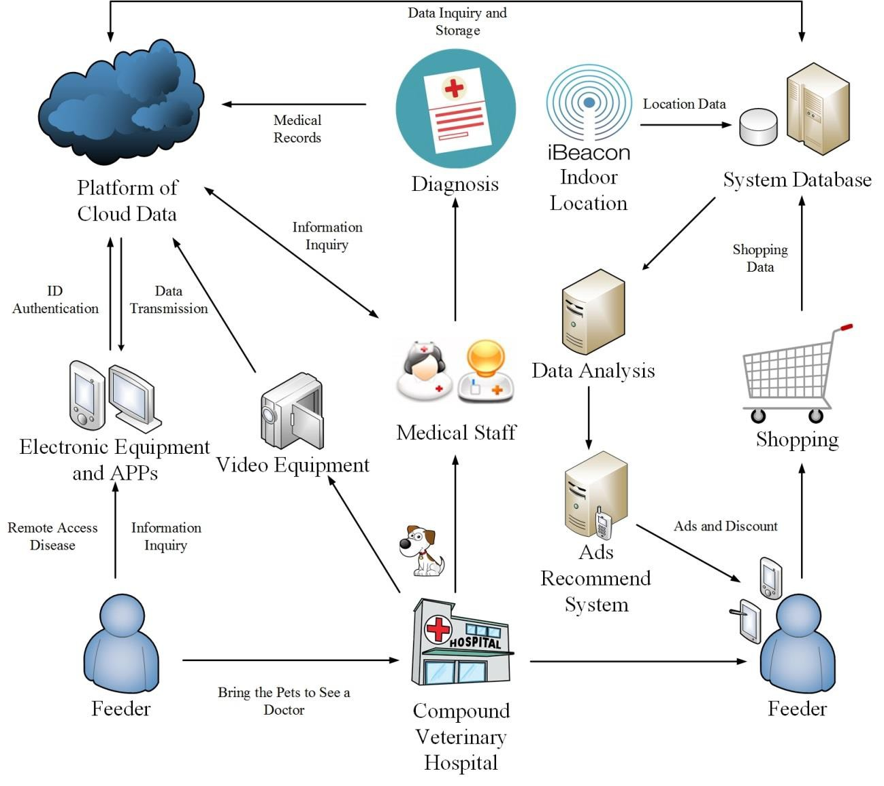Along with the emergence of compound hypermarkets, pet owners would take the pets to veterinary hospitals for complete care and purchase the required products, such as pet food, pet toys, and pet necessities, in the stores. For this reason, iBeacon is applied to the stores to acquire the real-time location of an owner to provide correspondent product information and the news of product offers. Meanwhile, the combination of pet medical care facilities and network information allows pet owners and veterinarians receiving the real-time pet medical care information and provides integrated Cloud platform. The research framework of this study is shown in Figure 3-1.

Figure 3-1 The Research Framework of Information System

A remote pet visiting and shopping recommendation platform is established with the idea of Cloud information integration in this study in order to enhance veterinary hospitals’ efficacy, reduce the costs, increase the operating efficiency of the overall process, and effectively apply medical information. Accordingly, both veterinary hospitals and pet owners would actively understand the information of both parties, and shopping offers and recommendation as well as consumer behavior analysis could be provided to promote owners’ shopping intention and enhance the overall business turnover. The application of Cloud platform, information technology, and the relevant equipment, e.g. iBeacon, video equipment, and mobile phones, could construct a favorable integration system to reinforce the trust between pet owners and hospitals and allow pet owners easily purchase relevant products in the stores when taking the pets to veterinary hospitals. It could therefore deal with the trust problem between both parties.

With the advantages of Cloud platform, the similar allied members are included in allied or chained veterinary hospitals, Figure 3-2. Allied member hospitals would upload relevant information, such as surgery processes, medical practice, medical records, drug use details, and consumers’ shopping details, to Cloud platform for mutual data connection so that the relevant people and hospitals could commonly use the information and share and exchange relevant contents for the reference of future medical treatment and decision making. When a pet owner doubts about the treatment process or question the surgery process of the pet, the relevant processes could be provided through Cloud platform for the comparison with allied hospitals to commonly inspect relevant information and processes so as to achieve the transparent medical practice and create closer trust between owners and hospitals. The competition in the industry becomes fiercer with the booming pet market. Veterinary hospitals have to think of finding out competitive advantages in the competitive market environment. Cloud information platform is utilized for the research framework in this study to save

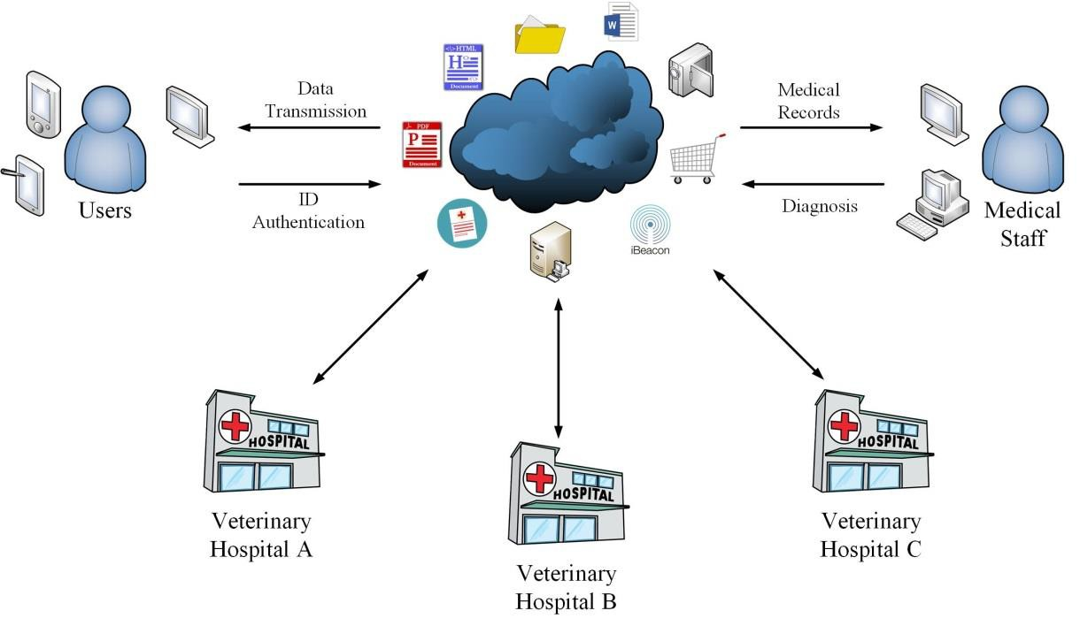the demand for manpower and maintenance costs to break the boundary of independent operation of past veterinary hospitals, and to provide new-style service methods and decision-making analyses with new information technology. It not only could solve common medical disputes but could also analyze consumers’ purchase habits, through consumer behavior analyses and purchase habit analyses, to provide the analysis related to product sales and to further enhance the business profits of large compound veterinary hospitals.

Figure 3-2 Concept of Integrated Cloud Platform

The product recommendation system process in this study is shown in Figure 3-3. A pet owner brings the pet to see a doctor and downloads the correspondent APP after the mobile phone and identity authentication. The owner and the pet are then given the iBeacon positioning transmitter, which would grasp the location of the pet in the medical practice process. Meanwhile, the owner’s location in the store is recorded. After entering the store, the owner could acquire the real-time information, images, and location of the pet through the electronic device. Meanwhile, the iBeacon receiver could acquire the owner’s data and, according to the owner’s location in the store, give the notices related to product information and offers. When the owner has consumed in the

store, the historical records would be analyzed with the data analysis system to predict the preferred pet brand and the required products of the owner as well as provide offers, such as coupons and store promotion.

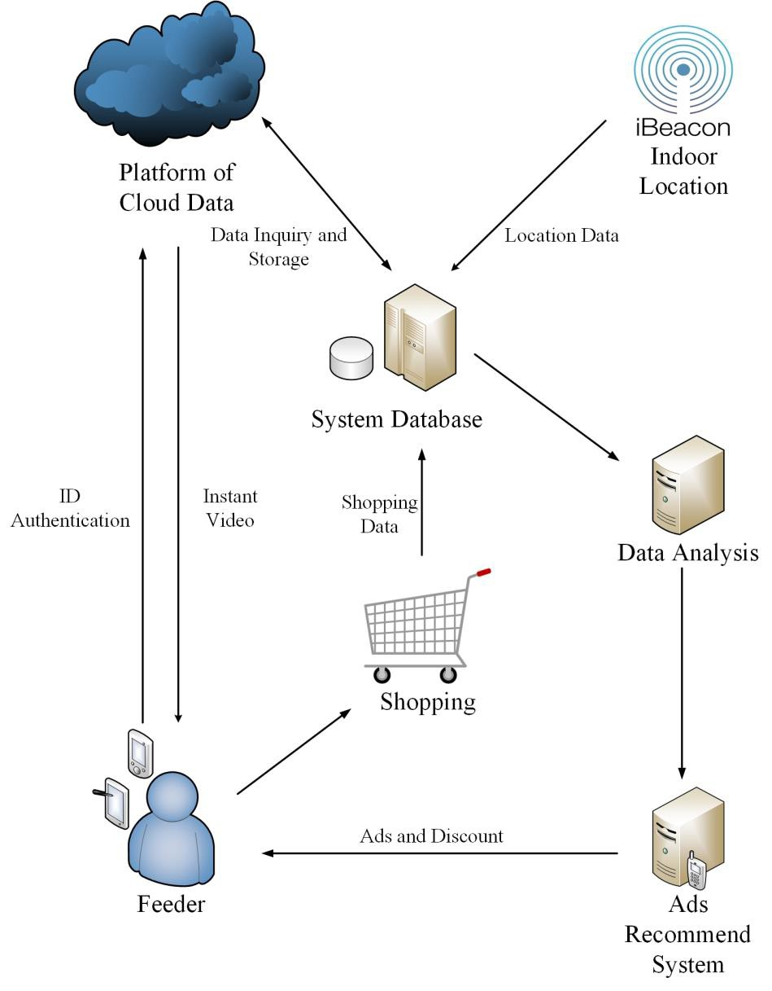

Figure 3-3 Process of Product Recommendation System

The integrated Cloud service platform in this study is designed according to existing mechanisms and environment requirements to present the comprehensive communication between pet owners and medical units and effectively utilize medical information. The pet’s location could be grasped with iBeacon at any time, and the radio frequency identification technology (RFID) could read the information in the pet’s chip

and allow the owner registering the system for managers managing the information of pets and members. The pet image data recorded with the video equipment could provide medical staff for monitoring the conditions in a pet’s ward. A pet owner could connect to Cloud service platform through the electronic device and APP for pet information enquiry or remote visiting the hospitalized pets as well as acquiring relevant recommendation and offers when shopping in the store.

## Section II Platform Establishment and Planning

Cloud service technology allows businesses not being restricted to the use of physical equipment, simplifies service procedures, and provides differentiated services for the relevant application of veterinary hospitals on Cloud service platform. Based on “Large compound veterinary hospital infrastructure” and “Cloud service platform framework”, the establishment of Cloud service platform is discussed in this section so that the integrated system framework and mechanism could meet the practical requirements and enhance hospitals’ intention to apply such a framework and mechanism in the future.

1. Large compound veterinary hospital infrastructure

Large compound veterinary hospitals contain enormous data, including information related to pet medical care and stores. Various allied members show different customer sources that, when allied members upload and save relevant information in the Cloud server, the data would be completely transmitted to Cloud service platform, with the protection of information security, to win customers’ trust by entirely protecting the data and privacy. The infrastructure established in veterinary hospitals contains “iBeacon device”, “data analysis system”, “video equipment”, and “storage”. When a pet owner shops in a pet store during the pet’s medical practice, iBeacon would accurately grasp the

locations of the owner and pet through positioning, and the number of signal receivers for iBeacon would be established based on the store size and spatial distribution. The owner, when shopping in the store, would be analyzed the preference, according to the past purchase records and the real-time positioning, and provided relevant offers to the mobile phone APP. During the pet’s medical practice, the medical procedures could be recorded and monitored through video equipment. When the pet returns to the ward, the living situation could be recorded through the camera. Under the 180° or 360° panorama, the owner could view the real-time picture of the pet. Storage would save pet medical care procedures, pet real-time images, owner’s purchase records, and owner’s positioning information, and the recorded medical procedures could be the reference for any medical disputes in the future. Purchase records and positioning information could be used in the data analysis system to provide the most suitable offers for the owner.

1. Cloud service platform framework

Cloud computing is basically composed of various layers of visual technology, and the framework is to transmit reliable services through the data center. A pet’s data file could be copied to the global storage server through the dynamic distribution and rapid copy algorithm of Cloud technology so that the user could connect the Cloud service platform through the mobile phone APP. Cloud service platform could carry large quantity of data. There might be thousands of data transmitted among veterinary hospital allied members. In order to stabilize Cloud service platform and meet the requirements, it is necessary to establish or rely on Cloud technology suppliers to establish the cluster server computing center to cope with daily data enquiry and message exchange of veterinary hospitals and users. Veterinary hospital allied members

therefore have to establish a steady Cloud center to complete the daily works of veterinary hospitals and users. The Cloud framework is the integration of platform, equipment, and software into the private network of hospitals, and the infrastructure and related resources in the cloud are established in the network firewall for institutions or departments in a company sharing the related resources in the data center.

## Section III Advantage of Integrated System

During the development of information technology, the technological application of distinct software and hardware has become mature. Along with the era of big data, many sales businesses start to emphasize consumers’ purchase records. Membership cards or the information of checkout systems to record consumers’ consumption records are therefore promoted, when data mining is used for exploring valuable data in consumer data. Ordinary statistical analyses use sampling to collect some data and generalize the population with such samples. However, such a method could not complete deduce the population in some situations, and there might be errors. Different from the ordinary statistical analyses, big data analysis directly analyzes the population of specific groups that deduction is not necessary for the analysis, but consumers’ relevant information could be directly analyzed. There are plenty of applications on the Internet, e.g. users’ browsing records, purchase behavior, time on page, and comment & evaluation, to analyze consumer behaviors. Nevertheless, physical stores could merely collect data through membership cards or real-name consumption records to analyze historical records. The combination of iBeacon with information systems could provide managers with decision-making reference and decision-making points from different aspects as well as provide new business models for stores changing owners’ passive consumption habits. The stores therefore could discuss consumer preference and

behaviors through data collection and analyses, actively promote with advertisement, and recommend and introduce relevant products. In addition to providing pet owners or consumers with an alternative choice, it could enhance the purchase intention of pet owners and consumers. Meanwhile, a pet owner could know the location and the treatment process of the pet to monitor the location and the real situations of the pet during shopping.

Veterinary hospitals and pet stores used to consider the expertise but seldom considered the needs of pet owners and pets. Nonetheless, the market structure is changing with enhancing importance of pets that traditional veterinary hospitals and pet stores could not simply rely on the past processes, without taking innovation into account. Current veterinary hospitals are divided into traditional paper-based operation and information system managed veterinary hospitals. Paper-based operation is time and manpower consuming and would waste a lot of spaces such that it does not meet modern management for efficiency. The latter, on the other hand, could not make adjustment to cope with the time because of the inadequate understanding of information technology so that effective solutions could not be immediately proposed for the market demand. It therefore results in certain gap with new-generation people’s habits. An integrated system combined with the application of big data and added the data analysis systems in Cloud platform is therefore proposed in this study. In addition to helping veterinary hospitals enhance the management efficiency, it also assists store-compounded veterinary hospitals in effectively marketing the products and making decisions through data.

By integrating video technology and equipment into this study, the full monitoring and recording of pet medical care is provided, allowing the owner viewing the medical practice of the pet at any time. When the surgery is completed and the pet is moved to a general room, both the veterinarian and the owner could check the recovery situation

and the living situation after the surgery through the real-time video images. For any doubts about the medical care results, the image record could be retraced for the judgment of decision-makers and the related people. The enhancing service quality and functions provided by veterinary hospitals could effectively promote pet owners’ trust and increase the intention to entrust the pets. Under the management of information platform, veterinary hospitals could largely reduce costs for manpower and objects as well as enhance the interaction and trust with pet owners.

# Chapter IV System Design

## Section I System Construction Requirement

According to the requirements of the integrated system, server software/hardware equipment and network equipment conforming to the requirements are established in this study. Table 4-1 shows the equipment requirements of the integrated system. In regard to iBeacon Bluetooth signal transmitter, the model number HL-2541TP-iB is selected and BLEv4.0 transfer protocol is utilized for supporting iBeacon standard communication protocol, mainly for indoor positioning and advertisement. Raspberry Pi

3 processor with ARM Cortex-A7 900MHz, 64 bits and 4 cores, is used for the Bluetooth signal receiver. In comparison with the previous two generations, Raspberry Pi 3 is compatible to more operating systems so that third-generation Raspberry Pi is used as the Bluetooth signal receiver. JCNet’s Hermes Q1100 with Intel Xeon 3400, which is a high-efficiency entry model and could support up to 32G memory, is selected for the central control server, as the special network decoding operation allows TCP/IP packet being directly operated on the network card, without taking up the use efficiency of CPU. For small and medium enterprises with limited resources, such a server presents better efficiency. In terms of statistical analysis software, R language is utilized. R language is free software especially for statistics and data analyses and presents high compatibility among different operating systems and rich packages. Famous brands of D-Link and Cisco are selected for wireless network and wired network. The Cloud service used in this study requires fast and stable environment that equipment with higher stability is adopted to reinforce the data transmission speed and reduce the equipment failure. In the beginning of the system establishment, basic equipment is set in a veterinary hospital and the collected pet medical information, product information, positioning information, and images are uploaded to the common Cloud platform or the

physical storage server for related people smoothly operating relevant functions after the establishment. It could enhance the management efficacy and reduce the costs for manpower and maintenance of the veterinary hospital as well as reduce terminal users’ handling burden. Cloud service suppliers have better and complete resources for a veterinary hospital’s data rapidly handling and analyzing the large quantity of information within the shortest time. Cloud service, similar to a super computer, provides network service efficacy, allowing small and medium enterprises reducing the costs for physical equipment and providing high-efficacy software service. For this reason, the major computation and storage in this study are achieved through Cloud technology to reduce the burden on physical servers.

Table 4-1 The Equipment Requirements of the Integrated System

|  |  |  |
| --- | --- | --- |
| Equipment | Name | Specification |
| Hardware | iBeacon | HL-2541TP-iB |
| Raspberry Pi 3 | Broadcom BCM2836 900MHz ARM  Cortex-A7 |
| Central Control Server | JCNet Hermes Q1100 |
| Wireless Network Equipment | D-Link DIR-885L Wireless AC3150 |
| Wired Network Equipment | CISCO SRW224G4-K9-NA 24Port  Switch Hub |
| Storage Equipment | TVS-873-64G 8-Bay NAS |
| CPU | Intel Xeon 3400 |
| Network Interface Card | 4 x Intel I210AT |
| Memory | 32GB |
| Monitor Video Equipment | i-family IF-001D 1080P |
| Network Video Equipment | TENVIS TH-661 HD |

|  |  |  |
| --- | --- | --- |
| Software | Operation System | Linux/Microsoft Windows Server 2016 |
| Data Analysis Software | R Script |
| Database Software | My SQL |
| Cloud Service | Amazon Web Services |
| Mobile  Device | Operation System | Android/iOS |
| Device Name | Sony、Samsung、Asus、Acer、APPLE |

## Section II Owner System Function

Along with the popularity of smart phones and mobile network, people would take mobile phones with them to anywhere. According to the 2016 survey of eMarket, the population of smart phone users in Taiwan was about 73.4%, which became the highest smart phone penetration in the world. According to the 2016 survey of NCC, about 64.4% population in Taiwan used 4G mobile web-browsing service [62], revealing the popularity of mobile web-browsing and smart phones. Moreover, the hot issue of mobile payment in Taiwan has various financial businesses follow the trend and carry with biometric mobile payment allowing people taking mobile phones, instead of wallets, with them; such mobile phones combine the functions of applications and payment. Mobile phone APP are integrated into this study to provide pet owners with real-time pet-related information, including pet information, real-time images, medical information enquiry, and information sharing, so that pet owners could thoroughly understand the pets’ medical records, physiological records, and relevant medical knowledge. Besides, a pet’s real-time medical procedures, life situations after the surgery, and related surgery records could be viewed through the real-time image system. The period for a pet staying in a hospital would change with the degree of surgery and medical processes. A long period is required for a major surgery that a pet owner would feel comfortable about a veterinary hospital which is able to provide the

real-time pet information platform for the owner concerning about the pet’s situations at any time. Such a function allows a pet owner not worrying about the pet in the hospital as well as the veterinary hospital promoting the business characteristics and satisfaction and reducing medical disputes caused by asymmetric information between both parties. What is more, iBeacon is also combined in this study to acquire the locations of a pet and the owner in a compound veterinary hospital. When a pet owner takes the pet to a veterinary hospital, the veterinarian would provide the owner and pet with the Bluetooth signal transmitter through a wristband and the pet’s collar and equip Bluetooth signal receivers corresponding to the size of the compound veterinary hospital to accurately position the locations of the pet and the owner in the compound veterinary hospital so that the owner could check on the location of the pet and the proceeding procedures at any time. According to the positioning of the owner in the shopping, the system would transmit relevant offers and production related information to the owner’s mobile phone APP so as to enhance the purchase intention. In this case, the mobile phone APP functions to provide hot sales, coupons, and latest news. The proposed integrated system functions are described as follows:

1. Owner authentication

When a pet owner, for the first time, brings the pet to see a doctor, the veterinarian would store the basic data of the owner as well as the pet’s number and medical records in Cloud platform and ask the owner to download the proposed mobile phone APP, which is bound with the telephone number and basic data, to confirm the owner’s identity for successive analyses of the owner’s consumption records in the store and behaviors. Moreover, the owner would be provided relevant product recommendation through the product recommendation system. Meanwhile, the owner could check on the pet’s medical records and location through the binding with the APP account so that the owner could acquire

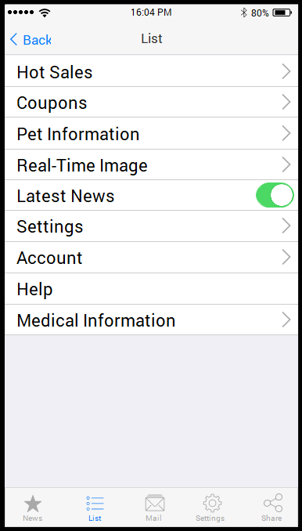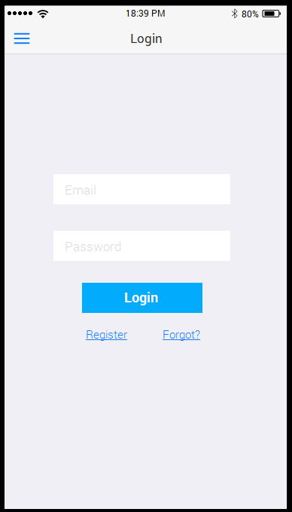the pet’s real-time information wherever the Internet is connected and feel comfortable about the veterinary hospital. The owner authentication and the APP binding could benefit the management and real-name data analyses of the back-end system. Meanwhile, if the pet is the high infection group of specific diseases, the real-name management of owner authentication could directly advise the owner of correspondent prevention knowledge and measure to effectively manage the customers. The mobile phone APP log-in interface is shown in Figure 4-1, and the relevant functions provided in the mobile phone APP are listed in Figure 4-2.

Figure 4-1 Log-in Interface Figure 4-2 Relevant Function

1. Hot sales and coupons

The statistics of all consumers’ shopping data and the analyses of products consumed by different pet owners through the product recommendation system could provide hot-sales product information and coupons aiming at individual

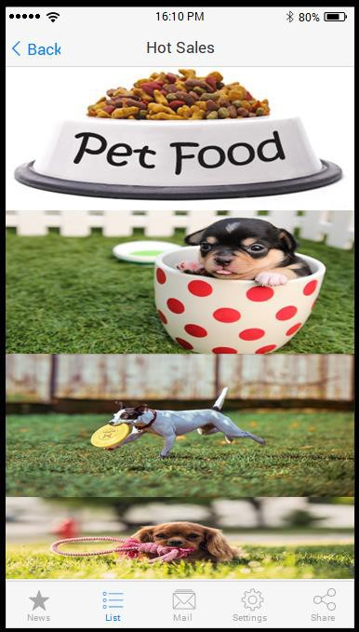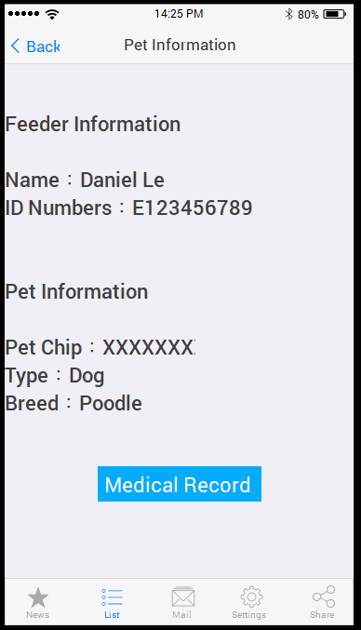owners. According to the past product information of different pet owners in a pet store as well as an owner’s moving track and the staying time at product selves in the store recorded by iBeacon, the data are analyzed for recommending hot-sales products so that the owner could directly inquire such hot-sales products and information on the mobile phone APP. Besides, according to the location of a pet owner detected by iBeacon, product coupons correspondent to the product shelves are provided for the owner. Meanwhile, according to a pet owner’s purchase records in the store, the consumption behaviors and preference are analyzed for giving the product coupons and offer notice to enhance the incentive to purchase the products and further promote the overall business turnover of the store. The hot sales and coupon interface is shown in Figure 4-3.

Figure 4-3 Coupon Figure 4-4 Pet Information

1. Pet information

A veterinary hospital would store a pet’s medical information to Cloud platform for the owner and the veterinarian trace and inquire the relevant medical information at any time. It could be the reference of a veterinarian’s treatment, allow a pet owner checking on the pet’s physiological message and medical records, and remind the owner of recording the situation and health conditions of the pet after the surgery or general treatment as the important reference for next treatment. A veterinary hospital could apply customized marketing according to the pet information recorded by the owner, such as notice of return visit, vaccination, and product offers. In addition to the function of transparent medical information, it could provide a pet owner with the pet’s health information at regular time in order to enhance the health recovery of the companion pet. The pet information interface is shown in Figure 4-4.

1. Real-time image

When shopping in the store or intending to concern about the pet’s situation in the veterinary hospital, a pet owner could connect to the real-time image system on Cloud platform through the mobile phone APP to acquire the pet’s online real-time images. A veterinarian, on the other hand, could take care of the pet in the veterinary hospital through the real-time image system to timely discover and handle abnormal conditions. The real-time image interface is shown in Figure 4-5.

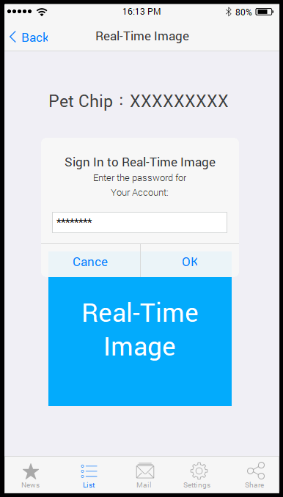

Figure 4-5 Real-Time Image Interface

1. Medical information enquiry

The system function allows pet owners inquiring relevant medical problems, including pet diseases, pet vaccines, pet related knowledge, and disease prevention knowledge. It could also transmit pet owners’ problems, through the message transmission system, to veterinary hospitals for responses. Meanwhile, veterinary hospitals could also send real-time message, e.g. pets’ abnormal state and treatment results, to pet owners through the system, which then becomes the communication bridge between pet owners and hospitals. It could help a pet owner establish relevant pet knowledge to enhance the pet companion’s quality of life as well as achieve the idea of preventive health care to provide a more complete medical knowledge network.

1. Information sharing

In the advanced information technology era, the development of community networks is prosperous and a lot of businesses contain network marketing in the business strategies. Check-in and sharing articles and pictures are the most powerful information communication in network marketing. The function of information sharing is therefore proposed in this study, allowing a pet owner directly using the APP provided by a veterinary hospital and sharing the contents, such as the pet’s real-time images, medical information provided by the medical information enquiry system, and considerate messages sent from the message transmission system. A pet owner’s sharing could promote the service provided by a veterinary hospital and, coping with the trend of the time, expose good systems and good services in public.

1. Latest news

The system proposed in this study presents the function of latest news reminder, which could be set for receiving, so that a pet owner could grasp the latest real-time information of a veterinary hospital and the hospitalized pet, and product and treatment offers of the veterinary hospital could be sent to owners. When there is research on special disease infection, specific owners would be noticed of the relevant pet medical care knowledge, health safety, and health care to achieve the objective of prevention.

## Section III Manager System Function

Cloud service platform has been broadly applied currently, and a lot of system data and functions have been integrated to existing systems through Cloud service. Cloud service platform provides information and system services so that veterinarians, veterinary hospital operators, and system managers could operate veterinary hospitals

through Cloud system and manage the synchrony of veterinarian and owner (customer) systems. Aiming at different roles and functions, including veterinarians, operators, and system managers, the proposed system is demonstrated as follows:

* 1. Veterinarian

Veterinarians are those engaging in veterinary hospital related affairs, including veterinarians, assistants, and nurses. Pet medical staff mainly serves clients and satisfy clients’ needs. This system provides relevant functions for medical staff assisting veterinarians in taking care of pets’ medical practice, grasping the health conditions, and immediately and professionally dealing with pets’ physiological problems. Figure 4-6 shows the veterinarian system functions.

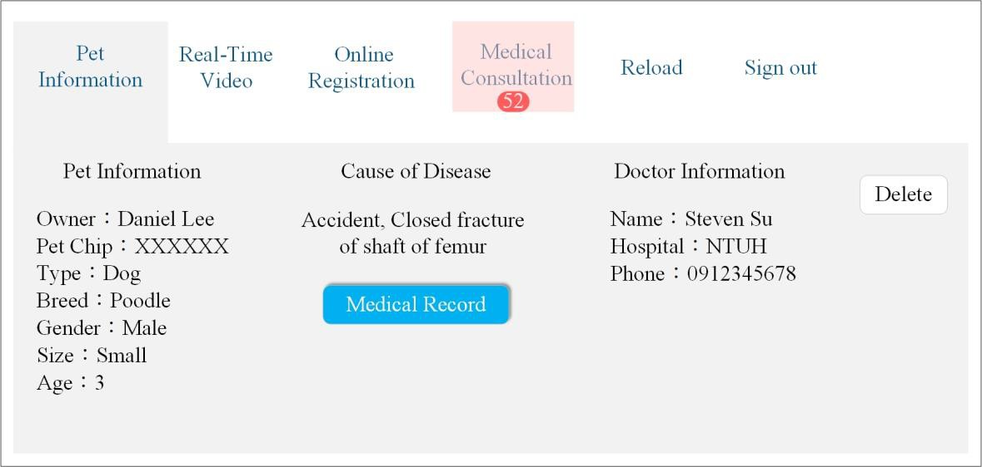

Figure 4-6 Veterinarian System Functions

* + 1. Pet medical care record

Pet medical care record system mainly records pet-related medical information. Pet diseases and prescriptions recorded by veterinarians are transmitted to the Cloud server database, including pet’s chip number, owner, variety, figure, size, illness factor, medical records, and veterinarian’s data. The system would record a pet’s diseases and the prescriptions for the

reference of the owner and the veterinarian at the next visit. A pet owner, on the other hand, could acquire the pet’s medical records through the mobile phone APP.

* + 1. Real-time video

By equipping real-time video equipment in pet medical care wards and medical rooms for veterinarians monitoring pets’ living situations and recovery conditions could effectively reduce the time and process of inspection by people. Meanwhile, the abnormal state of a pet could be observed through the real-time video equipment. When problems occur, it could reduce delay treatment caused by inadequate information resulting in a pet not being timely placed. Veterinarians, on the other hand, could manage wards through the system to promote the service quality of the hospitals.

* + 1. Registration system

Online registration system is the trend of a hospital’s informatization. A pet owner could log in the bound identity account and password through the mobile phone and precede online registration for the pet, instead of waiting in line and going through complicated registration procedures. The owner then could take the pet to the veterinary hospital in the arranged time interval. For filing the registration system database, a pet owner’s personal basic data and the pet’s data are required, such as name, address, pet’s name, and pet’s variety. A veterinary hospital could effectively release the flow of people and manage the number of registering people through the system to enhance the administration and management efficiency as well as maximize the time to see pets.

* + 1. Medical consultation system

Medical consultation system is a bidirectional system. When a pet owner,

with the medical information enquiry or message delivery system on the mobile phone APP, sends problems related to pet medical care, disease prevention, pet health care, and others to a veterinary hospital’ system, the system would automatically notice the veterinarian of such medical enquiry service. The veterinarian, on the other hand, could directly respond to the owner’s mobile phone APP through the system in order to maintain the communication between the hospital and the owner.

* 1. Operator

An operator grasps the business direction of the veterinary hospital and the store and presents the key role in the future strategies of the veterinary hospital. Sufficient information is required for judging the direction of a veterinary hospital and the problem handling method. For this reason, the establishment of a complete information decision-making network is the key to an operator managing the overall quality of a hospital. Figure 4-7 shows the operator management platform interface. All data, images, and medical records are covered in the operator’s system authority.

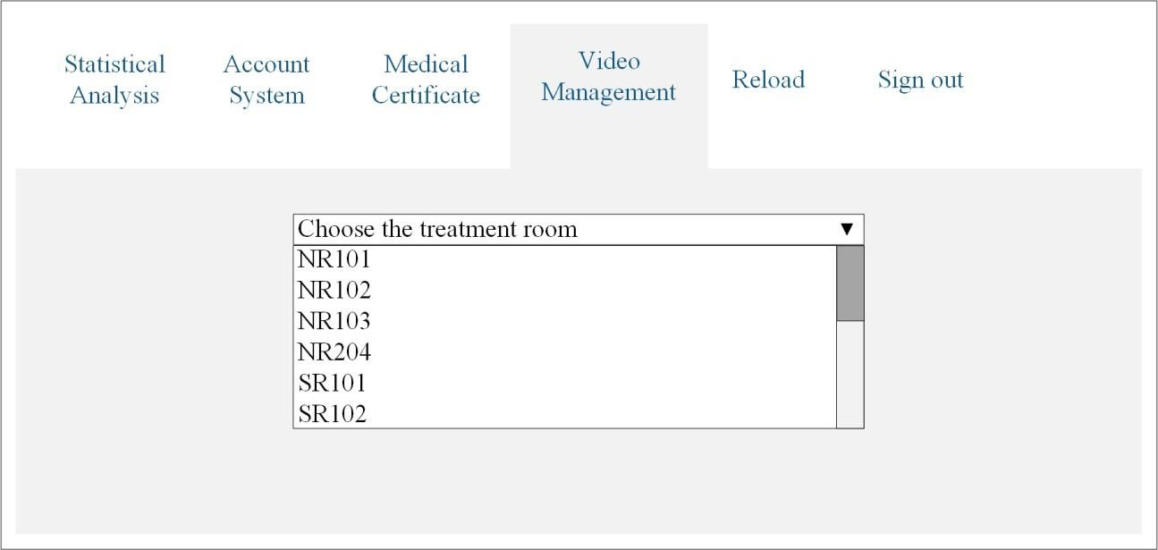

Figure 4-7 Operator Management Platform Interface

* + 1. Store product statistical information

The integrated system proposed in this study would generate large quantity of data because of the integration of system procedures, including product sales information in the veterinary hospital store, indoor positioning information of pet owners, real-time video images, medical records, and hospitals’ accounts of receipts and payments. An operator could analyze relevant statistical information for the reference of business decision-making. With the data analysis, the average time for surgery, data mining results of products, consumer behaviors, and the operating income and expenditure of the veterinary hospital could be acquired.

* + 1. Accounting system

Accounting system is integrated into Cloud platform in this study. Besides, the combination with the statistical analysis system allows an operator directly viewing the operating situation and accounting financial statements of balance of account, balance sheet, cash flow statement, income statement, and statement of changes in equity of the veterinary hospital to inspect the financial situation of the veterinary hospital for judging the future business.

* + 1. Hospital medical certificate

When pet owners or the outside world question about improper surgery processes, improper pet treatment processes, and improper care from veterinarians, veterinary hospitals could provide real-time video images of pets in pet wards and surgery rooms as well as relevant medical certificates and records stored in Cloud platform as the effective and direct medical evidence to reduce medical disputes.

* + 1. Video image management

Managers could select the real-time images in a ward through the treatment ward list. The function could be used for inspecting the pet care situations in various areas and monitoring improper care from veterinarians, if any. Meanwhile, operators could grasp the firsthand message, control the situation, and urgently handle crises when emergent situations or exceptional events appear in hospitals.

* 1. Information system manager

Information system manager is the platform technology and maintenance staff of a veterinary hospital, mainly in charge of maintaining the system operation and dealing with exceptional events and maintaining information security to prevent from Internet attacks causing the collapse of hospital systems and the loss of hospitals. Regular data backup in Cloud and redundancy could prevent data from loss caused by natural disasters and unpredictable disasters. Since the development of Cloud platform is mature, system maintenance and management of Cloud platform entrusted to Cloud service suppliers could effectively reduce hospital’s costs. However, information staff in hospitals should be able to understand the maintenance of information systems, data security, incident handling, and regular data backup as well as contact with Cloud service suppliers for the normal operation of veterinary hospitals. Figure 4-8 shows the information system manager function.

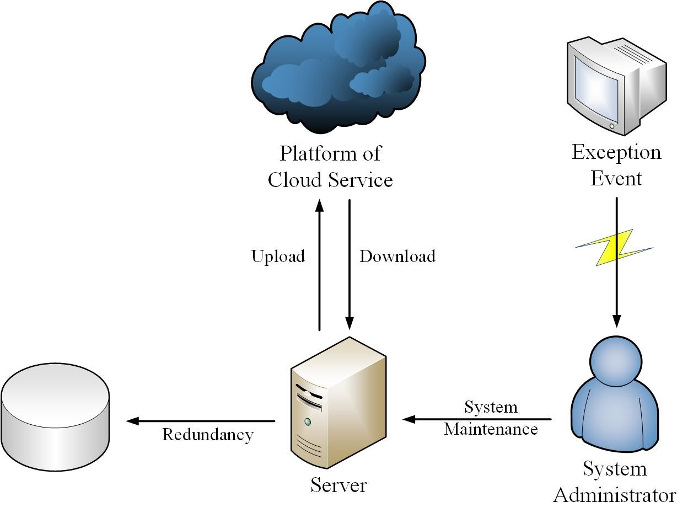

Figure 4-8 Information System Manager Function

* + 1. System maintenance

Maintaining the stability of information management system could reduce unnecessary loss that a major duty of an information system manager is to maintain the stable operation of systems. System managers therefore have to understand the operating principle and operation of systems as it relies on the crisis processing capability and spontaneous responses of system managers when problems occur. Particularly, the fluency and function of mobile phone APP and the operation of information system in veterinary hospitals should be kept fluent to ensure the service quality and enhance the customer satisfaction. Data loss resulted from unstable information systems and the effect on the operating loss of hospitals could be reduced while enhancing customer satisfaction.

* + 1. Information security

Current Cloud computing technology still exists in security risks. Data security and privacy, which could result in serious loss of an enterprise when

being stolen or damaged, need reinforce the protection. In physical information environment, information managers could apply other methods to maintain or remedy afterwards to reduce the damage down to the lowest. However, information security problems caused by Cloud service suppliers would be hard to remedy under the structure of Cloud computing. Relatively, enterprises would spend higher costs on information security maintenance and management. In this case, information managers should present sufficient knowledge and technologies on information security protection to prevent from the loss caused by information security problems. The transmission of hospital data to Cloud platform should be ensured of virus-free, and system managers have to establish antivirus protection mechanisms and the network section of firewall.

* + 1. Exceptional event

System management tool would alert with sound and window, when the system appears abnormality, to remind information system managers and relevant technicians of confirming the exceptional event and solving the abnormal problems to maintain the system stability.

* + 1. Data backup

Veterinary hospital related data are the important asset of a veterinary hospital. As a result, backup is an important investment. When the system appears problems, the data could be timely searched back to prevent from loss caused by disasters or error operation.

# Chapter V Conclusion and Future Work

## Section I Research Conclusion

Following the changing family structure in the society, a lot of people entrust the mind to pets. Some scholars even promote the name as companion animal. The enhancing status of pets in a family has the family members increase the concerns about pets, regard them as family members, and expect to treat them as people. It therefore enhances the development of pet industry, including pet medical care, pet beauty, pet stores, and pet hotels. Compound veterinary hospitals developed in the past years combine veterinary hospitals or beauty shops with pet stores to provide innovative business model, in which operating costs are reduced by bulk purchase and the overall service quality is enhanced by the application of complete pet service procedures to attract customers. Nonetheless, the application of information technology to veterinary hospitals has not been popularized. Meanwhile, the business model in pet industry is changing constantly. A lot of veterinary hospitals could not catch up with the business trend. This study therefore expects to provide veterinary hospitals with the integrated information technology to promote the capacity and reinforce the competitiveness.

The system proposed in this study combines iBeacon, the indoor positioning technology, with the medical care system applied in Cloud service platform and provides an integrated system for compound veterinary hospitals to enhance the management efficiency and the overall business turnover. iBeacon is applied to acquire the real-time location of a pet owner and provides the correspondent product information and product offer news. With the combination of Cloud platform and information system, the system proposed in this study allows a pet owner connecting to Cloud platform, through the mobile phone APP for relevant information and functions, including hot sales, coupons, pet information, real-time images, medical information

enquiry, information sharing, and latest news. The services of product offers, medical information enquiry, and latest news are the connection bridge between pet owners and hospitals, and the pet information and real-time image records could reduce medical disputes between pet owners and hospitals caused by opaque medical practice. The system records allow medical information and surgery processes being public and transparent to reduce pet owners’ distrust of veterinary hospitals. The integrated system could reduce administrative procedures and human care costs to enhance veterinarians’ service quality. The integrated system could also store surgery process images and medical information for the case study examples among veterinarians as well as experience exchange and sharing among hospitals. The data and statistical data accumulated in the established information platform could provide operators with reference for future business directions and decision-making of the veterinary hospitals. Consumer behaviors could be discussed through the analysis of product sales information to further determine the future business direction of veterinary hospital stores. The data mining technology could dig out the correlations among a pet’s infected diseases, variety, age, and figure for the reference of future medical treatment. Summing up above explanations, the integrated system proposed in this study presents the following advantages:

1. To provide operators with different marketing from the past through iBeacon, the indoor positioning technology.
2. To provide pet owners with offers through shopping recommendation system to enhance the purchase intention.
3. To connect the relationship between pet owners and veterinary hospitals through Mobile phone APP.
4. To provide pet owners with customized services through the data analysis system.
5. To reduce human care costs, decrease medical dispute risks, provide pet owners with the pets’ real-time images, and monitor the operating procedures of hospitals through real-time video.
6. To reduce administration costs and enhance administration efficiency with the establishment of Cloud service platform.

## Section II Research Restriction and Future Work

It is difficult to seek for the cooperation with manufacturers or the government because of the high rental for the proposed veterinary hospital infrastructure and Cloud service platform as well as limited time and manpower that this study mainly discusses the system framework. It is expected that a small part of system implementation could realize the system establishment and seek for the cooperation with manufacturers and the government to complete the proposed system framework. In the future, questionnaire survey or interviews could be utilized for directly acquiring the actual needs for the information system from veterinarians or pet owners so as to complete the information system to provide information services close to the relevant people.

The development of Cloud technology is quite mature, and information manufacturers are competing in the market. Under the fierce competition, general consumers and small and medium enterprises are benefited. For instance, Google, Amazon, and Microsoft provide Cloud platform services, allowing small and medium enterprises not spending large amount of costs for establishing physical equipment. Many hospitals present the trend of informatization nowadays. However, few integrated information systems are offered for veterinary hospitals. It is therefore expected that veterinary hospitals could effectively apply Cloud resources and establish more effective medical information management systems to replace the existing medical management procedures and provide better services.

# References

1. , J. H. (2006). Animal Communication： Pets as Intermediaries in Interpersonal Interactions (Unpublished master’s thesis). Shih Hsin University, Taipei.
2. Hsing, H. F., Wang, I. C., and Tseng, H. T. (2010). The Impact of Pet's Death on Modern People, *Chinese etiquette*, Vol. 22, No. 1, pp. 49-52, Jul, 2010.
3. , H. P. (2016, July 22). Do You Worry About No One Take Care of Your Family? Mobil House Keeper Makes You Worry About Nothing for Housework. Retrieverd from <https://www.gvm.com.tw/webonly_content_10267.html>
4. Chiang, S. M. (2010).A Study of Veterinary Market in Taiwan (Unpublished master’s thesis). National Taiwan University, Taipei.
5. Tang, F. M. (2013, Jan. d.). The Industrial Development of Pet and Relevant Management Measures in Recent Taiwan. Retrieverd from [http://www.coa.gov.tw/ws.php?id=2446815](http://www.coa.gov.tw/ws.php?id=2446815ï¼Œ2013/05/29)
6. Chen, Y. F. (2014). An Implementation of Video Telecare Platform for Veterinary Hospital (Unpublished master’s thesis). Tunghai University, Taichung.
7. Animal Protection Information. (2015, n. d.). The Statistical Data of Home Dogs and Home Cats in Taiwan in 2015. Retrieverd from <http://animal.coa.gov.tw/html/index_06_1_Y104.html>
8. Open Platform of Agricultural Information. (2017, n. d). Veterinary Practitioner License. Retrieverd from <http://data.coa.gov.tw/>
9. Yu, F. W. and Lo, K. L. (2016, Dec. 12.). Through Statistical Data to Analyze the Situation of Animal Market Development in Taiwan. Retrieverd from [http://atiip.atri.org.tw/Report/PubReportShow.aspx?rpt_guid=f002901b-278a-4980](http://atiip.atri.org.tw/Report/PubReportShow.aspx?rpt_guid=f002901b-278a-4980-8028-8e51dea81cd5)

[-8028-8e51dea81cd5](http://atiip.atri.org.tw/Report/PubReportShow.aspx?rpt_guid=f002901b-278a-4980-8028-8e51dea81cd5)

1. American Pet Products Association. (2017, n. d.). Pet Industry Market Size & Ownership Statistics. Retrieverd from <http://www.americanpetproducts.org/press_industrytrends.asp>
2. Tsai, L. C. and Tien, P. Y. (2013, Feb. 27). The Situation and Development of Pet Market’s Supply Chain. Retrieverd from <http://gcis.nat.gov.tw/like/Plan/TechReportDetail/432>
3. Tsou, J. C. (2011). Interrelation Between Service Quality, Customer Satisfaction, Customer Loyalty In Animal Hospital Industry (Unpublished master’s thesis). National Chiayi University, Chiayi.
4. Chang, N. C. (2011). Customer’s Perception on Service Satisfaction – An Empirical Study of Animal Hospitals (Unpublished master’s thesis). Chung Hua University, Hsinchu.
5. Liu, Y. L. (2009). The Study of relevance among Quality of Service, Customer Satisfaction, Customer Loyalty, and Consumer Behavior – An Example of Compound Animal Hospital (Unpublished master’s thesis). National Formosa University, Yunlin, 2009.
6. Kaufman, L. M.. “Data Security in the World of Cloud Computing.” *IEEE Security & Privacy*, Vol. 7, No. 4, pp. 61-64, Aug, 2009.
7. K. Hwang. “Massively Distributed Systems : From Grids and P2P to Clouds.” in

*International Conference on Grid and Pervasive Computing*, Berlin, 2008, PP. 1-1.

1. M. Dejan. “Cloud Computing: Interview with Russ Daniels and Franco Travostino.”

*IEEE Internet Computing*, Vol. 12, No. 5, pp. 7-9, Sep, 2008

1. Hsu, P. H. (2012). Model of Cloud Services – Senior Home Care Cloud Service Case Study (Unpublished master’s thesis). National Taiwan University of Science and Technology, Taipei.
2. Chen, P. R. (2013). The Influencing Factors of Introducing of Cloud Computing Services-Using Companies in Kaohsiung Software Technology Park as an Example (Unpublished master’s thesis). National Pingtung University of Science and Technology, Pingtung.
3. A. Mladen. “Cloud Computing – Issues, Research and Implementations.” *Journal of Computing and Information Technology*, Vol. 16, No. 4, pp. 235-246, Jun, 2008.
4. I. Foster, Y. Zhao, I. Raicu, and S. Lu. “Cloud Computing and Grid Computing 360-Degree Compared.” in Grid Computing Environments Workshop, Austin, 2008, pp. 12-16.
5. Huang, C. H. (2009, Mar. 20). Basic Introduce Cloud Computing, Skill Forum. Retrieverd from <http://www.cc.ntu.edu.tw/chinese/epaper/0008/20090320_8008.htm>l
6. Yu, C. and Lu, I. C. “Cloud Computing and the Revelation of Learning Everywhere toward Public Sector’s Development of Digital Learning.” *National Academy of Civil Service*, Vol. 91, pp. 67-73, Mar, 2010.
7. Singularity Hub. (2017, May 19). Cloud Computing on the Rise – The World Mind is Upon Us. Retrieverd from <https://singularityhub.com>
8. Mell , P. and Ling, T. (2011, Sep. d). The NIST Definition of Cloud Computing. Retrieverd from http://nvlpubs.nist.gov/nistpubs/Legacy/SP/nistspecialpublication800-145.pdf.
9. E. Park, H. Kim, and J. Y. Ohm. “Understanding driver adoption of car navigation systems using the extended technology acceptance model.” *Behaviour & Information Technology*, Vol. 34, No. 7, pp. 741-751, Oct, 2014.
10. McFedries, P. (2008, Aug. 1).The Cloud Is the Computer. Retrieverd from https://goo.gl/gwYPy6
11. C. T. Chung, T. C. Kao, and C. H. Yang. “Cloud Computing and Development of Industrial.” *Research Bimonthly*, Vol. 4, pp. 20-31, Aug, 2010.
12. H. C. Peng and N. T. Chang. “The Discussion of the Information Security to Cloud Computing.” *the Manual of Council for Economic Planning and Development, and Control and Assessment Department*, pp. 172-192, 2010.
13. R. Buyya, C. S. Yeoa, S. Venugopal, J. Broberg, and I. Brandic. “Cloud Computing and Emerging IT Platforms: Vision, Hype, and Reality for Delivering Computing as the 5th Utility.” *Future Generation Computer Systems*, Vol. 25, No. 6, pp. 599-616, Jun, 2009.
14. L. M. Vaquero, L. R. Merino, J. Caceres, and M. Lindner. “A Break in the Clouds: Towards a Cloud Definition.” *ACM SIGCOMM Computer Communication Review*, Vol. 39, No. 1, pp. 50-55, Jan, 2009.
15. C. Y. Wu, C. Y. Wang, and T. W. Yang. “A Mobile Oriented Security System Based on Agent Theory and Cloud Technique.” *Journal of Southern Taiwan University of Science and Technology*, Vol. 3, pp. 39-54, Sep, 2012.
16. Chen, T. C. (2012). Management of Chain Animal Hospital over Cloud Service Platform – A Case Study on National Veterinary Hospital (Unpublished master’s thesis). Tunghai University, Taichung.
17. Lin, M. H. (2012). Evaluation and Research of Telecare Services Applied in Community Hospital for Outpatient Clinics Patients (Unpublished master’s thesis). National Sun Yat-sen University, Kaohsiung.
18. P. C. Kuszler. “Telemedicine and Integrated Health Care Delivery: Compounding Malpractice Liability.” *American Journal of Law & Medicine*, Vol. 25(2/3), 1999.
19. Wu, C. C. (2010). Development of the Diversified Healthcare System for Diabetics (Unpublished master’s thesis). Yuan Ze University, Taoyuan.
20. D. Pountney. “Identifying and Managing Guillain-Barré Syndrome.” *British Journal of Neuroscience Nursing*, Vol. 5, No. 8, pp. 381-383, Sep, 2009.
21. J. Barlow, D. Singh, S. Bayer, and R. Curry. “A Systematic Review of the Benefits of Home Telecare for Frail Elderly People and those with Long-Term Conditions.” *Journal of Telemedicine and Telecare*, Vol. 13, No. 4, pp. 172-179, 2007.
22. C. H. Chen, M. J. Su, H. L. Huang, S. C. Chen, Y. T. Tai, and H. S. Chen. “Distant Domestic Caring System.” *Taiwan Medical*, Vol. 6, pp. 837-845, Nov 2004.
23. E. R. Lewis, C. A. Thomas, M. L. Wilson, and V. W. Mbarika. “Telemedicine in Acute-Phase Injury Management: a Review of Practice and Advancements.” *Telemedicine and e-Health*, Vol. 18, No. 6, pp. 434-445, Jun, 2012.
24. M. M. Ward, M. Jaana, and N. Natafgi. “Systematic Review of Telemedicine Applications in Emergency Rooms.” *International Journal of Medical Informatics*,

Vol. 84, No. 9, pp. 601-616, Sep, 2015

1. J. J. Luh, H. S. Chen, P. H. Chen, and J. S. Lai. “Development and Realization of Telemedicine.” *Formosan Journal of Medicine*, Vol. 6, pp. 826-831, Sep, 2004.
2. A. B. Bynum, C. A. Irwin, C. O. Cranford, and G. S. Denny. “The Impact of Telemedicine on Patients' Cost Savings: Some Preliminary Findings.” *Telemedicine Journal and e-Health*, Vol. 9, No. 4, pp. 361-367, Jul, 2004.
3. Tsai, C. W. (2011). Software System Development of Telecare System Based On Cloud Technology (Unpublished master’s thesis). National Chung Cheng University, Chiayi.
4. Cheng, T. A. (2013). Design and Implementation of Intelligent Mobile Device Applications for Telehealthcare Systems (Unpublished master’s thesis). National Taipei University of Nursing and Health Sciences, Taipei.
5. Hsieh, M. H. (2010). The Research of Seniors Community Services Tele-health System Blueprint and Service Resource Model (Unpublished master’s thesis). Nan Kai University of Technology, Nantou.
6. Health Promotion Administration, Ministry of Health and Welfare. (2016, n. d).Health and Welfare Department of Health Care.” <http://mohw.telecare.com.tw/WebPages/Sidebar1/ProjectArea.aspx>
7. S. A. Hassan and Y. Li. “Medical Quality-of-Service Optimization in Wireless Telemedicine System Using Optimal Smoothing Algorithm.” *E-Health Telecommunication Systems and Networks*, Vol. 2, No. 1, pp. 1-8, Mar, 2013.
8. Wang, C. H. (2016). A Study of Care Management System for Chain Veterinary Hospital (Unpublished master’s thesis). Tunghai University, Taichung.
9. Huang, M. H. (2016). The Study and Improvement for Bluetooth Positioning (Unpublished master’s thesis). St. John's University, New Taipei.
10. Kao, C. C. (2010, Nov. 1). Low Power Consumption of Blue Tooth 4.0, Well Prospect or Harmful Threat. Retrieverd from <http://ppt.cc/1yV1E>
11. Lin, P. J. (2017). An Adaptive Mobile Hospital Indoor Navigation System by Using Beacon (Unpublished master’s thesis).Tunghai University, Taichung.
12. S. A. Thakkar, S. Patel, and B. Kamani. “iBeacon: Newly Emerged Technology for Positioning and Tracking in Indoor Place.” *International Journal of Advanced Research in Computer and Communication Engineering*, Vol. 5, No. 3, pp. 161-164, Mar, 2016.
13. Chu, Y. C. (2016). A Study of Indoor Location-awareness for People by Using the BLE Technology (Unpublished master’s thesis). Ming Chuan University, Taipei.
14. Hong, J. M. (2016). A Localization System Based on RFID and iBeacon Technology for Elderly People (Unpublished master’s thesis). Chaoyang University of Technology, Taichung.
15. Li, Y. R. (2015). Application of iBeacon Locating Technology with Data Mining for Shopping Recommendation APP at Retailer Store (Unpublished master’s thesis). National Taipei University of Technology, Taipei.
16. Sanathara, M. (2016, Aug. 22). IOS IBEACON APP TUTORIAL WITH SWIFT 2. Retrieverd from <http://www.alphansotech.com/blogs/ios-ibeacon-app-tutorial-swift-2/>
17. Y. Ohta, M. Sugano, and M. Murata. “Autonomous Localization Method in Wireless Sensor Networks.” in *Third IEEE International Conference on Pervasive Computing and Communications Workshops*, Kauai Island, 2005.
18. Lin, C. C. (2015). The Appliance of Beacon - Taking Exhibition and Market Commercial’s Message Spreading as an Example (Unpublished master’s thesis). National Dong Hwa University, Hualien.
19. Wu, C. Y. (2016). The Research on the Beacon Micro-location: A case study of Indoor Parking Space Management System (Unpublished master’s thesis). Shu-Te University, Kaohsiung.
20. Chang, S. C. (2015). NFC and iBeacon-based Smart Campus Patrol and Safety Reporting System (Unpublished master’s thesis). National Taiwan Normal University, Taipei.
21. Sodano, D. (2016, Dec. 16). Mobile Taiwan: A Look at a Highly Mobile Market. Retrieverd from <http://ppt.cc/vhfjH>